# Relative mass estimation using visual information from the Kinect sensor

Robert C Grande and Dr. Doik Kim

## Abstract

Estimating the relative mass and center of mass location of each limb is important for a variety of applications including realistic computer animations and robot teleoperation. In this work, the relative mass distribution of a person is measured using a Kinect sensor to measure the volume of a person. Then using methods from the ICRA submission, the density of each limb may be calculated. In order to approximately estimate the mass properties of a second person, the same densities are used from the first subject, and the mass is recalculated using the volume estimate from the Kinect.

## Method

The person stands in view of the Kinect camera with arms raised slightly above his/her head and legs slightly bent. This position helps the Kinect algorithm to detect the skeleton/pose of the person. After the skeleton has been successfully detected, the person should stand for no less than 2 full seconds in the same position to allow the algorithm to record the pose as well as the pixels in the Kinect output which correspond to the player.

After the algorithm has detected the person, it saves the x, y coordinates of the pixels corresponding to the human player every two seconds in a text file. In the MATLAB analysis file, the MATLAB file imports the text file and allows the user to pick an image that is sufficiently clear, such as the one below:

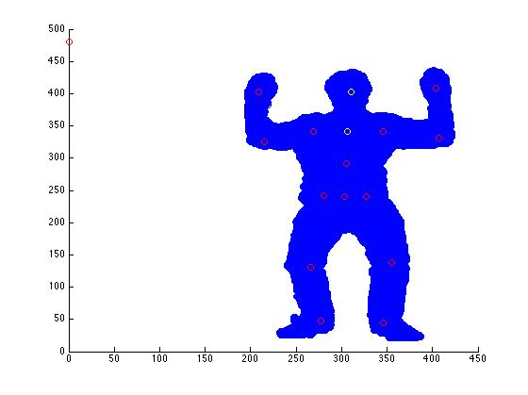

After an image has been selected, the MATLAB script highlights a joint in yellow. The user then selects four points that enclose a region that encloses the pixels corresponding to the joint. For example, in the first example, the user is shown a yellow head and neck joint. The user then must select a region in the picture corresponding to the neck head region, as follows:

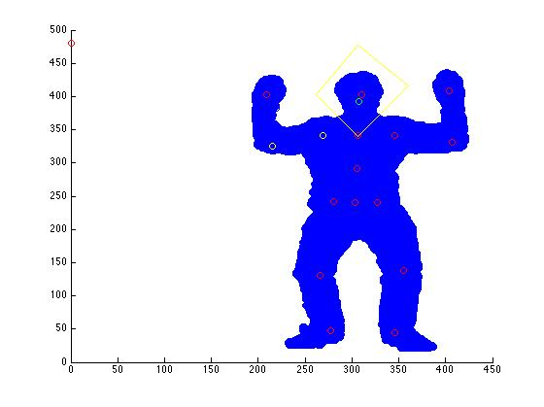

The user repeats this procedure for all joints:

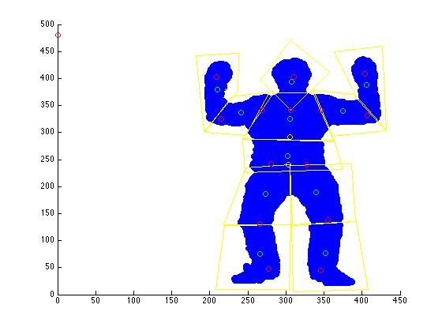

The algorithm calculates the centroid of each region, displays it in green, and also calculates the relative volume of each joint by counting the number of pixels in each joint, and dividing it by the total number of pixels. In order to find the density, the mass parameters calculated in the ICRA paper are divided by the relative volume. In order to get the mass of another person, the algorithm is repeated in part two of the program to calculate the relative volumes of the second person, and then the volumes are multiplied by the density from the first part

## Results

The following relative volumes, and densities were calculated for one subject. Rho corresponds to the projection of the centroid on the limb and then calculating the percentage of the distance that the centroid lies along the limb. See the ICRA paper for more details:

Person 1

|  |  |  |  |  |  |
| --- | --- | --- | --- | --- | --- |
| Name | Volume | Rho | Rho from ICRA | Mass from ICRA | Density |
| Head+Neck | 0.0582 | 0.8515 | 0.5408 | 0.0494 | 0.8487 |
| Left Upper Arm | 0.0417 | 0.4835 | 0.5704 | 0.0149 | 0.3576 |
| Left lower arm + hand | 0.0415 | 0.7087 | 0.7185 | 0.0107 | 0.2576 |
| Right upper arm | 0.0486 | 0.4967 | 0.5704 | 0.0149 | 0.3065 |
| Right lower arm + hand | 0.0416 | 0.6432 | 0.7185 | 0.0107 | 0.2573 |
| Left Upper leg | 0.1050 | 0.4933 | 0.3708 | 0.0891 | 0.8484 |
| Left lower leg + foot | 0.1423 | 0.6432 | 0.6379 | 0.0812 | 0.5707 |
| Right upper leg | 0.1076 | 0.4967 | 0.3708 | 0.0891 | 0.8282 |
| Right lower leg + foot | 0.1591 | 0.6450 | 0.6379 | 0.0812 | 0.5105 |
| Upper Torso | 0.1469 | 0.6681 | 0.5216 | 0.1193 | 0.8121 |
| Lower Torso | 0.1075 | 0.3152 | 0.5523 | 0.4394 | 4.0858 |

Person 2

|  |  |  |  |  |  |
| --- | --- | --- | --- | --- | --- |
| Name | Volume | Rho | Rho from ICRA | Mass from ICRA | Density |
| Head+Neck | 0.0555 | 0.7958 | 0.5992 | 0.1943 | 3.500900901 |
| Left Upper Arm | 0.0365 | 0.4926 | 0.5193 | 0.0106 | 0.290410959 |
| Left lower arm + hand | 0.0452 | 0.5738 | 0.6784 | 0.0106 | 0.234513274 |
| Right upper arm | 0.0358 | 0.5458 | 0.5193 | 0.0106 | 0.296089385 |
| Right lower arm + hand | 0.0376 | 0.6942 | 0.6784 | 0.0106 | 0.281914894 |
| Left Upper leg | 0.103 | 0.5573 | 0.4140 | 0.0360 | 0.349514563 |
| Left lower leg + foot | 0.1603 | 0.6389 | 0.6899 | 0.1223 | 0.762944479 |
| Right upper leg | 0.099 | 0.5473 | 0.4140 | 0. 0360 | 0.363636364 |
| Right lower leg + foot | 0.167 | 0.6147 | 0.6899 | 0.1223 | 0.732335329 |
| Upper Torso | 0.139 | 0.5931 | 0.4678 | 0.0255 | 0.183453237 |
| Lower Torso | 0.121 | 0.107 | 0.5487 | 0.4212 | 3.480991736 |

## Discussion

It is unlikely that this method will provide any accuracy accurate enough to be used in an application requiring fine precision, such as control of a humanoid robot. The Kinect sensor simply does not provide fine enough resolution to give high fidelity measurements of the volume. Additionally, it is unlikely that the density calculated will be similar among people of different age, sex, height, weight, etc. The advantage of this approach is that it only requires the Kinect sensor and is relatively easy and fast to implement. It may give a fast estimate of the mass parameters, however, it is not clear that the estimates here are better than using the averages reported in the literature. This is an area for future work.